 | How to share audio with zoom
This easy read guide will help you to
Share your computer sound to the other people in the meeting.
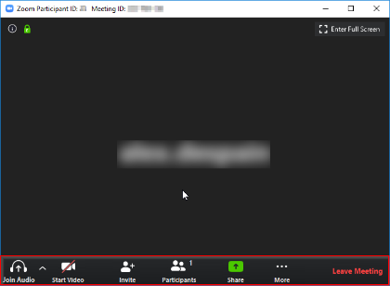 | - Step 1  When you are in a zoom meeting, if you move your mouse over the screen these options should pop up.
- Step 2
Please select the green button that says Share
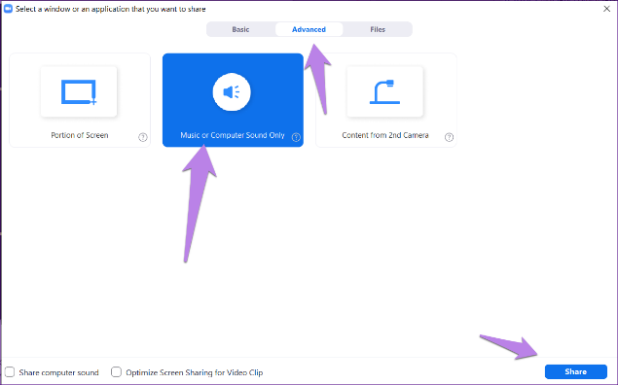 | - Step 3  If you are wanting to share AUDIO ONLY through zoom, On the share screen window in the top center where it says BASIC / ADVANCED, click the option for advanced, then click on the selection for COMPUTER SOUND ONLY. then press the blue share button.
 | - When you have finished sharing you need to select the stop share button, which will appear at the top of the screen.

