 | How to share your screen when using zoom
This easy read guide will help you to use the screen share option on zoom.
This means you will be able to share |music, videos and pictures to the other people on the zoom meeting.

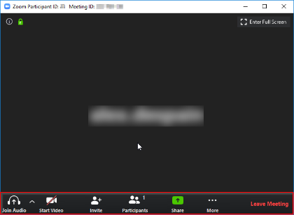 | - Step 1  When you are in a zoom meeting, if you move your mouse over the screen these options should pop up.
- Step 2
Please select the green button that says Share

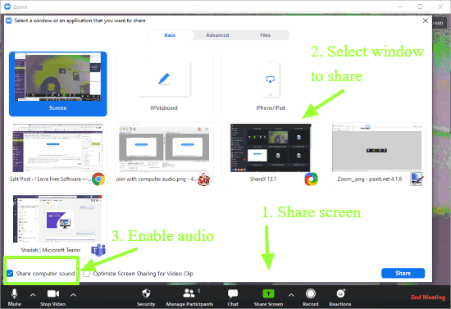 | - If you have other pages open like google, YouTube or a file these will show and you can select these screens to share.
 | - The green arrows are showing you what you need to select to share your screen and sound so people in the meeting can hear.
 | - When you have finished sharing you need to select the stop share button, which will appear at the top of the screen.

