 | How to join a Zoom meeting on a laptop
Zoom is an app where you can join video calls and virtual meetings with more than one person. You can use it on your laptop, tablet, or on a
smartphone
 | It is a good way of communicating whilst we are in this difficult time. It means we can still see and speak to each other over the internet
 | These are instructions for using Zoom on a laptop or computer
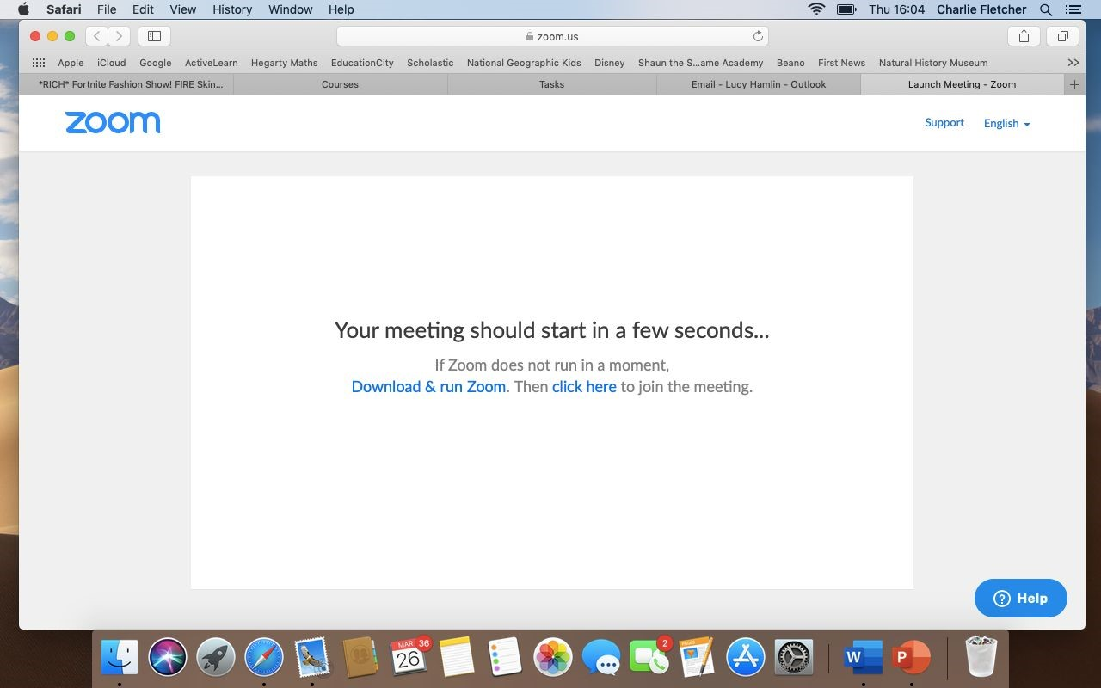 | The host will send you an email invite to join a Zoom Meet Up.
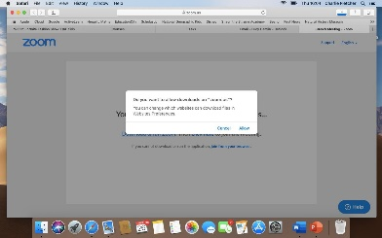 | You will need to download zoom in order to join the meeting  On the email you will also get a Meeting ID and password. You might need this to join the Meet Up

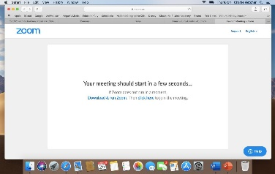 | Once downloaded, choose ​Click here
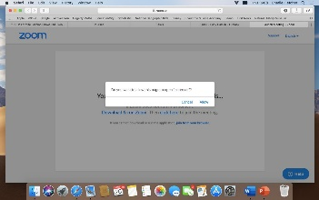 | It will ask if want the page to open zoom.us  Click Allow
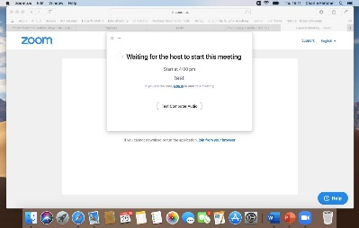 | If a screen like this appears you are in the Waiting Room. When it is time for the meeting to start your video will come on and you will see the host.
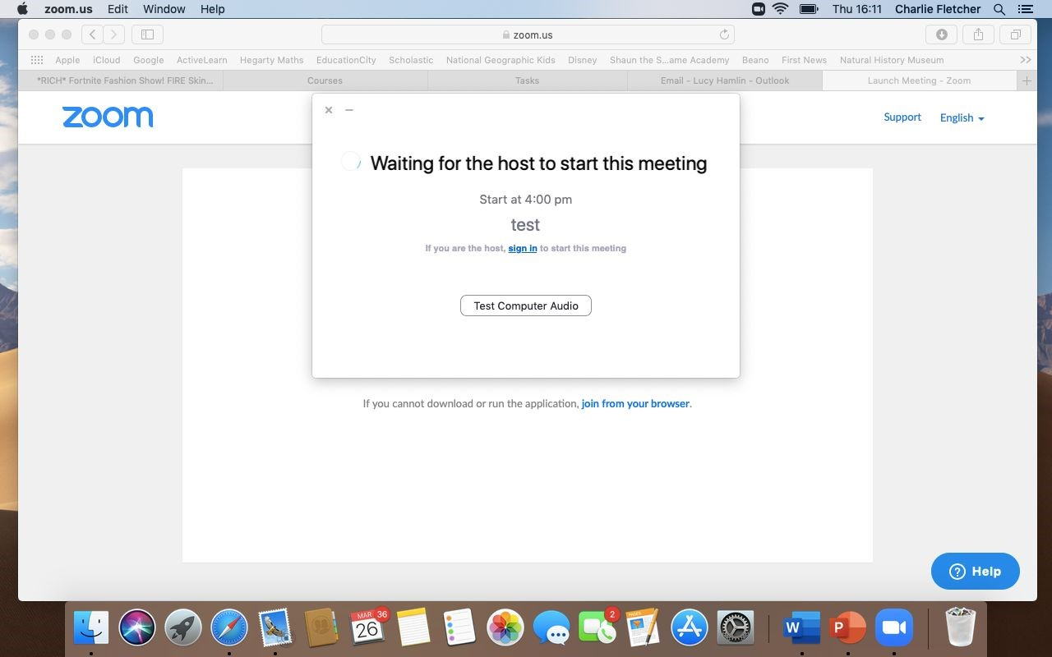 | Boxes might pop up to ask you to let Zoom access your microphone and camera.  You need to click “ok” so that you can speak and  be seen during meetings

